**Program 1:**

**1.Python**

**Program:**

import matplotlib.pyplot as plt

x = [1, 2, 3, 4]

y = [10, 20, 25, 30]

plt.plot(x, y)

plt.title("Simple Line Chart")

plt.xlabel("X-axis")

plt.ylabel("Y-axis")

plt.show()

**Output:**

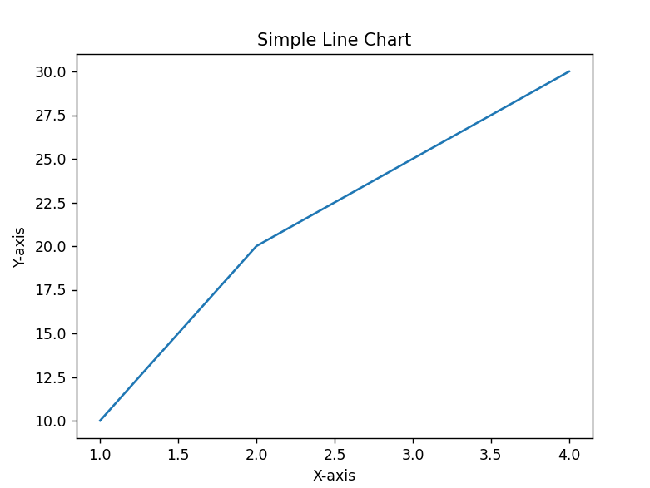

**2.R**

**Program:**

# Sample Data

categories <- c("A", "B", "C", "D")

values <- c(23, 17, 35, 29)

# Creating a bar chart

barplot(values,

names.arg = categories,

col = "orange",

main = "Bar Chart Example",

xlab = "Categories",

ylab = "Values")

**Output:**

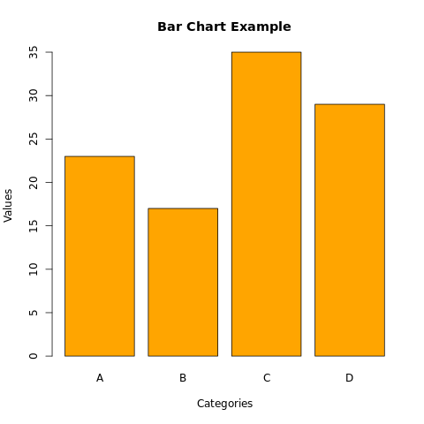

**3. Tableau Public**

**Program:**

**Stock.csv**

Section,Category,Detail,Year,AvgStockPrice

Marks,Automatic,Auto-Adjust,,,

Marks,Color,Blue,,,

Marks,Size,Large,,,

Marks,Label,Quarterly,,,

Data,AUG,Stock Price,2023,125.50

Data,SUM,Stock Quantity,2022,118.20

Analysis,YEAR,Annual Trend,2021,112.75

Analysis,AVG,Monthly,2020,105.30

,,,,2019,98.60

,,,,2018,92.45

,,,,2017,88.20

,,,,2016,85.00

,,,,2015,80.75

,,,,2014,76.40

,,,,2013,72.90

,,,,2012,68.30

,,,,2011,65.20

**Output:**

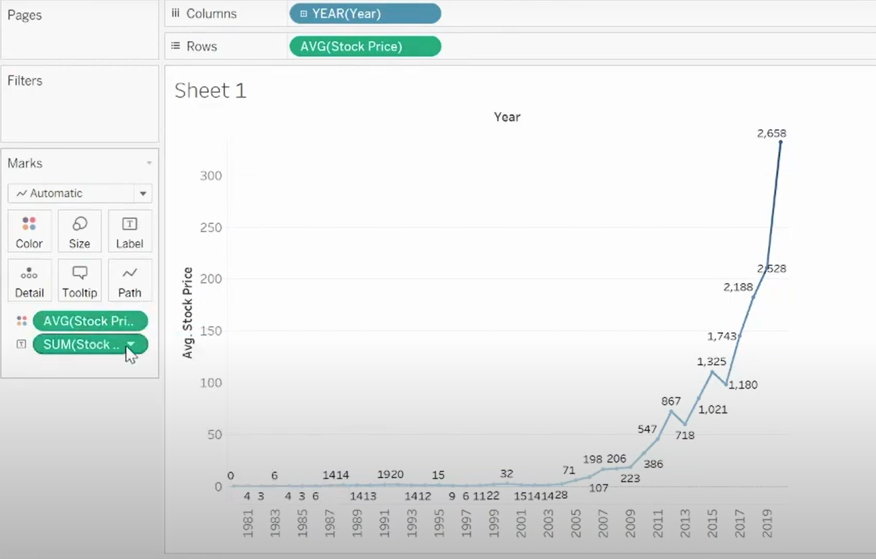

**4.PowerBI**

**Program:**

**Bank.csv**

Total Banks by State,Count,Count of Bank Name by Month,Count

GA,12,July,45

FL,18,October,32

IL,9,April,28

CA,25,January,50

MN,7,February,22

WA,14,May,38

AZ,11,August,29

MO,6,March,35

MI,8,September,27

TX,20,June,40

NV,5,November,18

KS,4,December,15

VII,3,Mean,30.5

CO,10,Total Banks,350

**Output:**

